Resource Group, Postgres DB

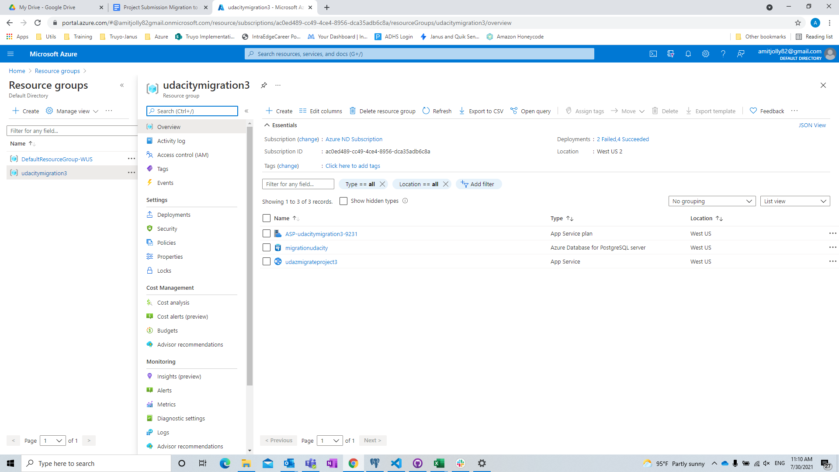

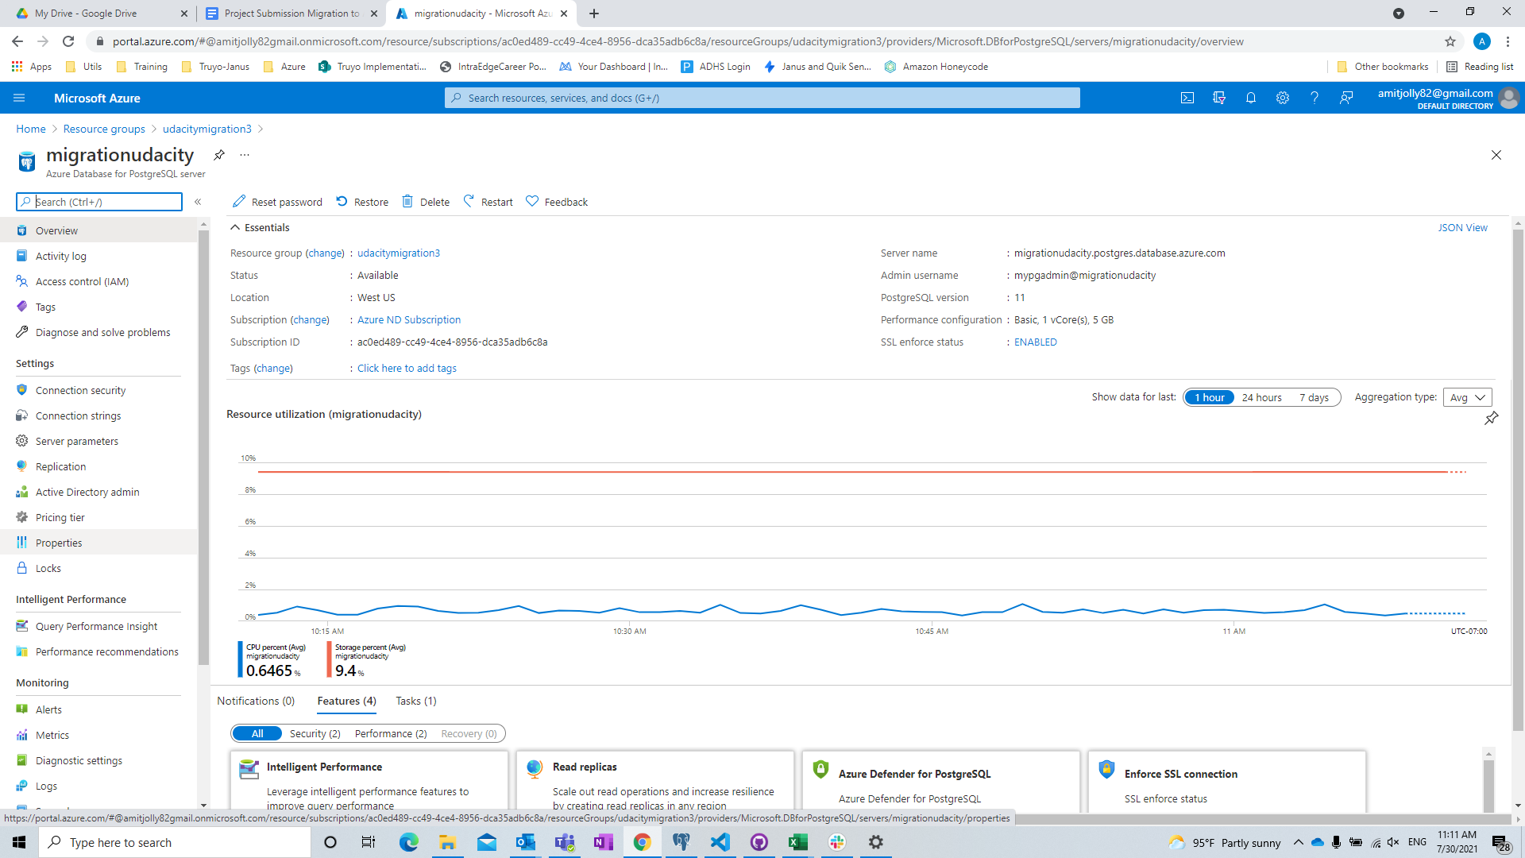

Allow all IPs:

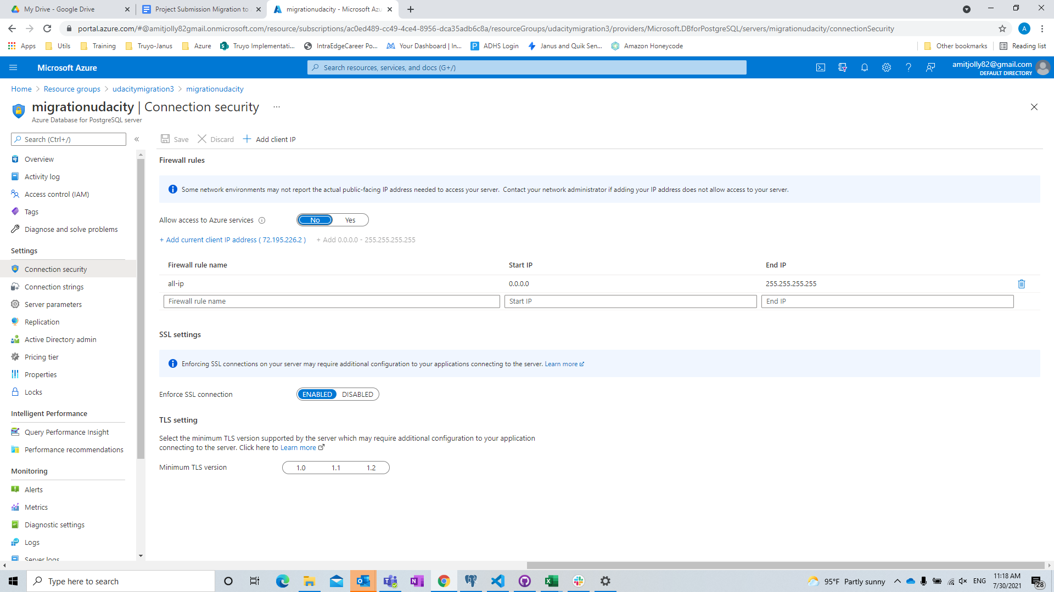

DB Created and back up restore from TAR file to Azure

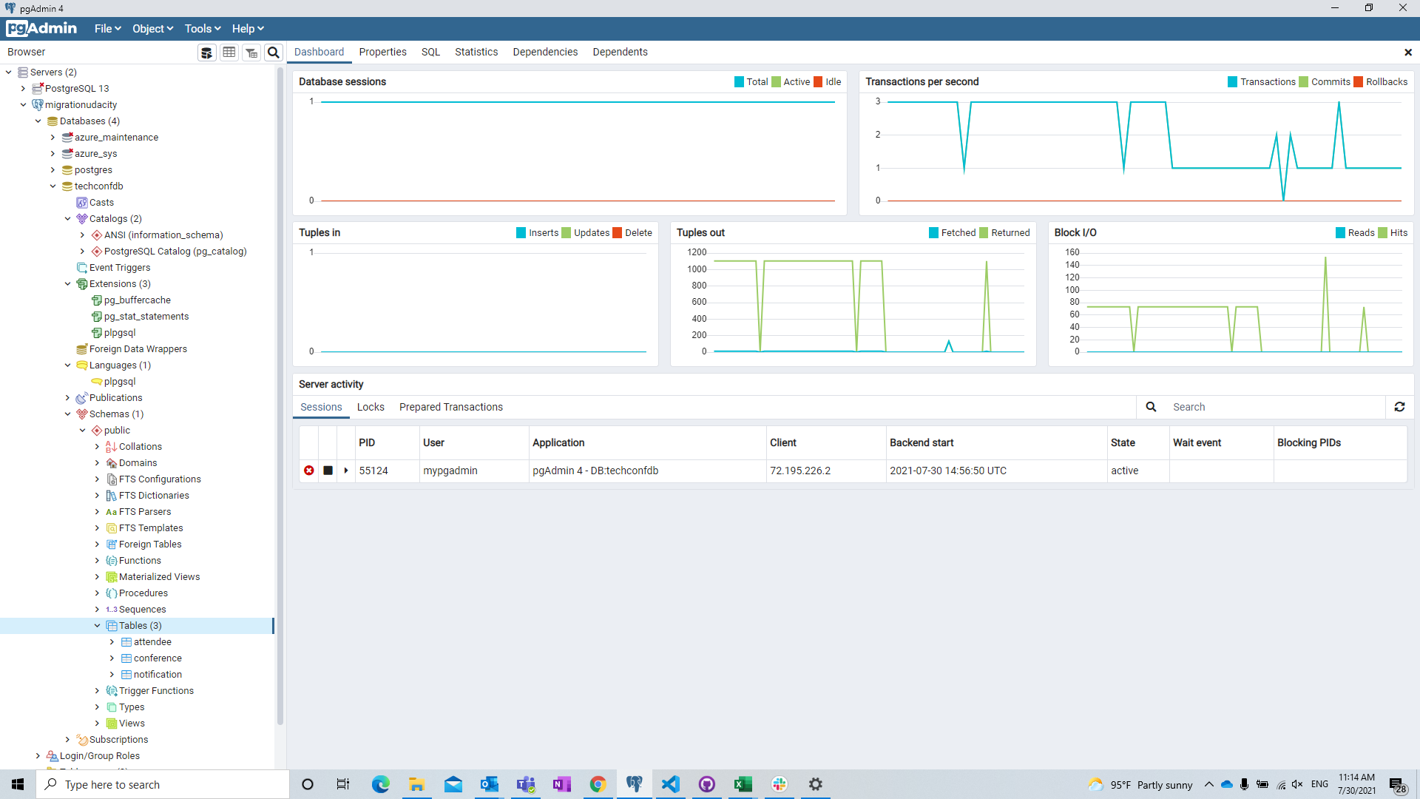

Webapp Resource:

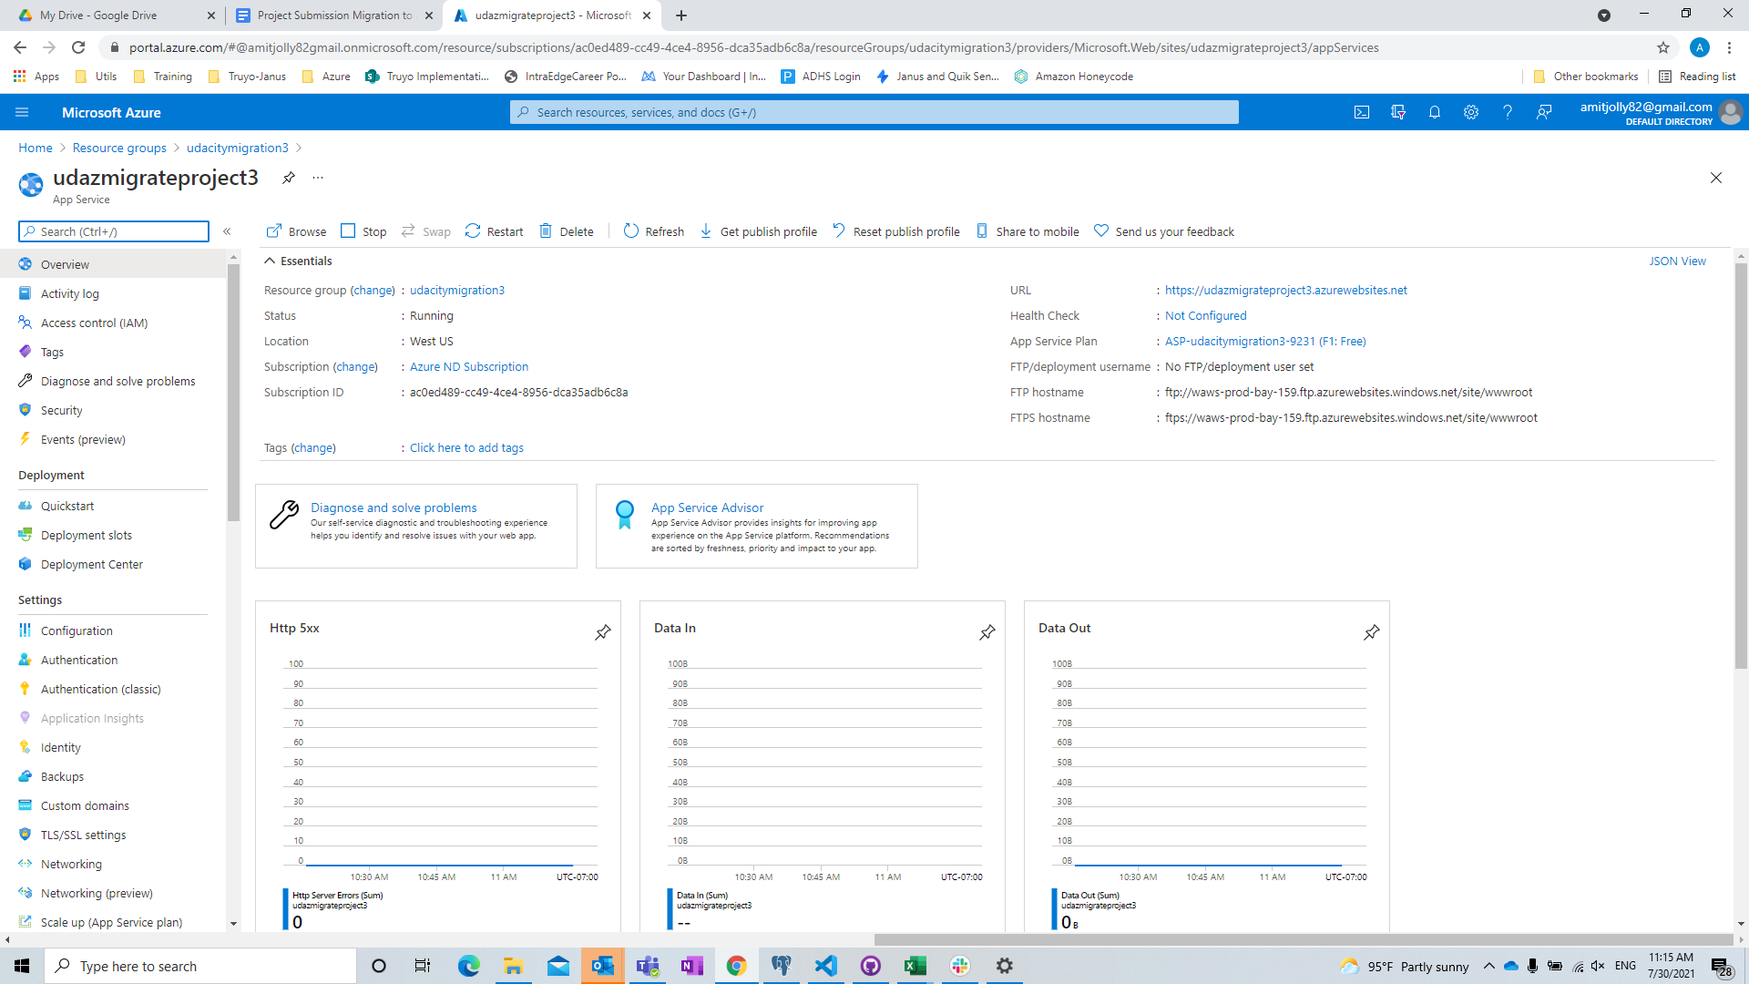

WebApp:



Service Bus Queue:

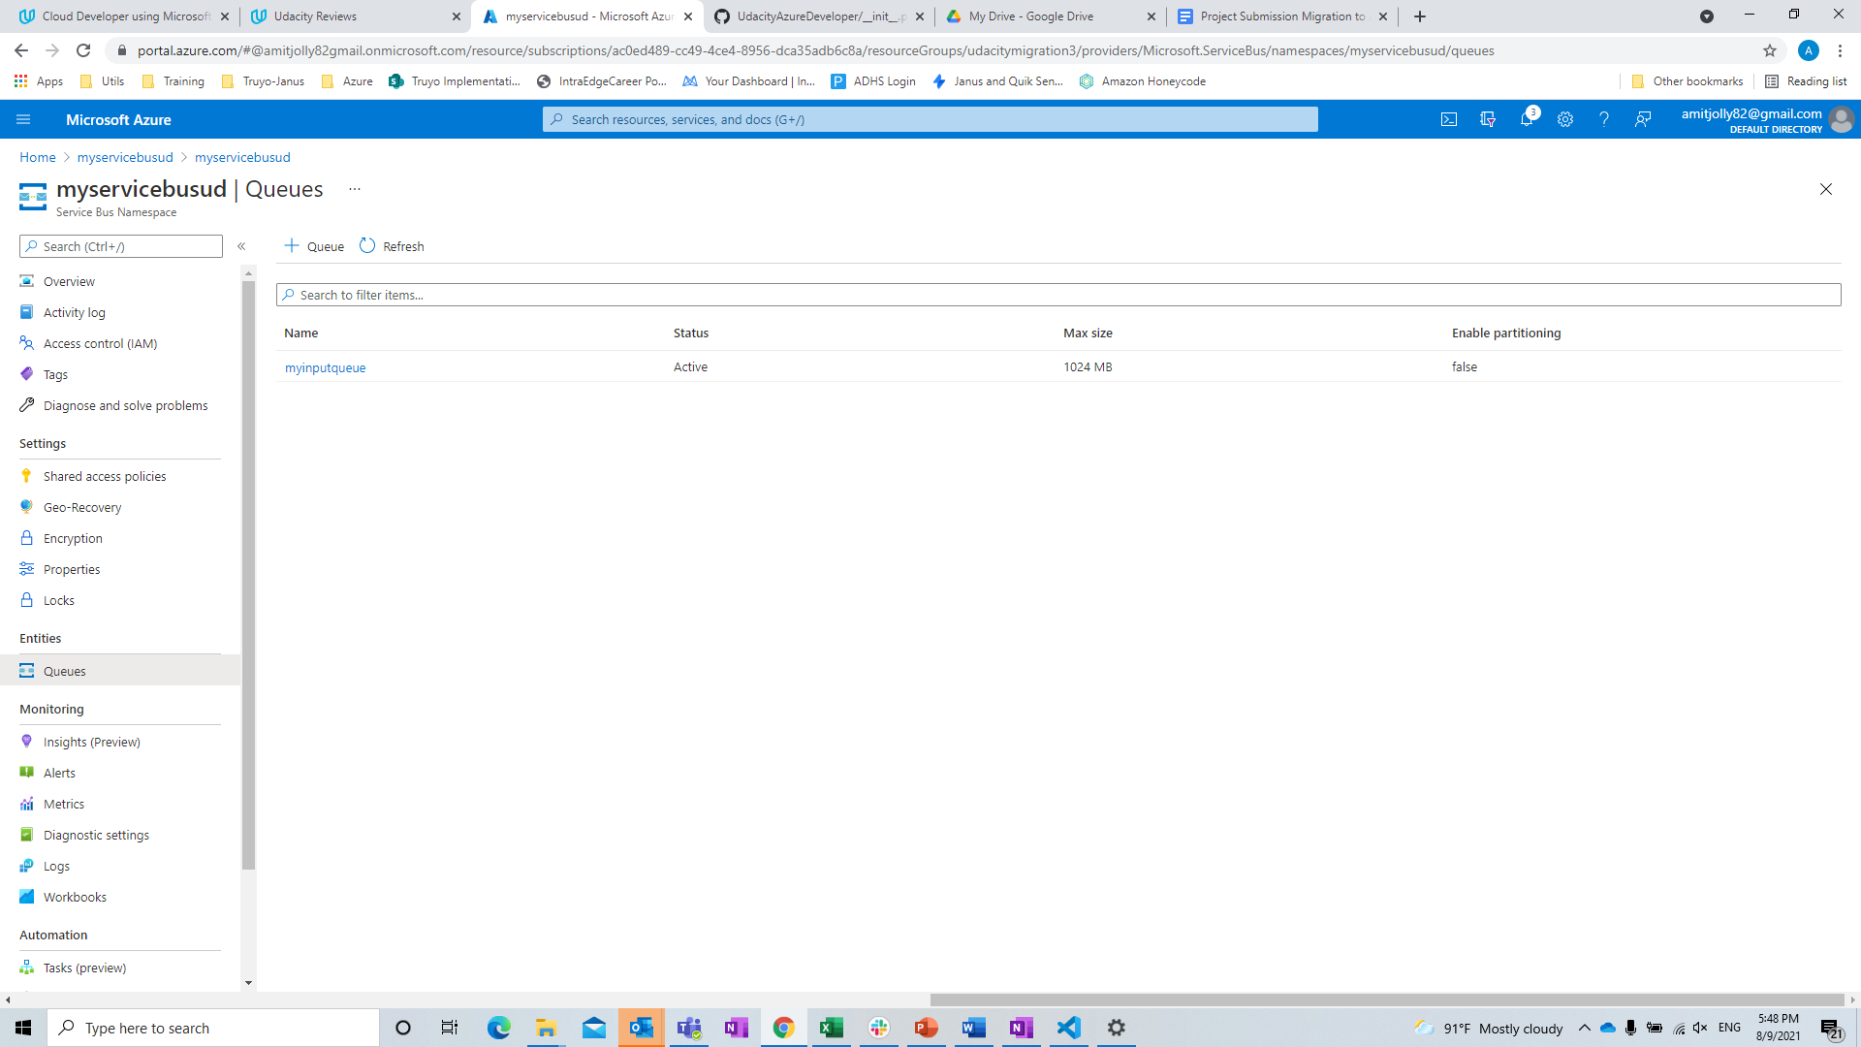

Function App Plan:

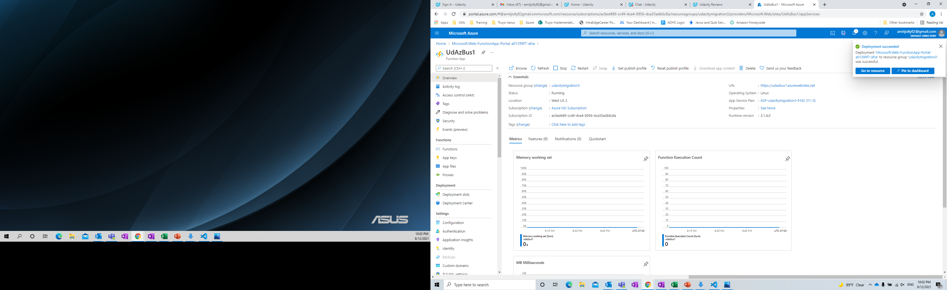

Init_py includedin zip file.

Routes.py included in zip file

Monthly Cost Analysis:

|  |  |  |
| --- | --- | --- |
| **Azure Resource** | **Service Tier** | **Monthly Cost** |
| Azure PostgreSQL | Basic | $43.55 |
| Azure Service Bus | Basic | $0.01 |
| Azure App Service | Basic (B1) | $21.12 |
| Azure Storage | Basic | $0.10 |

Architecture Explanation:

The azure web app was already built and the only requirement was to change the environment variables in config.py and refactor notification flow in app.py. Azure resources utilized for my project are available at a reasonable price.

The most expensive resource is PostgreSQL which was required as part of project rubric. However, for our testing, I opted for a basic plan only. Service Bus namespace to handle notification is also appropriate.

If I’d have to improve the design I’d have explored cheaper options for databases.

As far as deployment goes, creating a webapp resource and using Azure’s offered deployment option is far better and works seamlessly with github.